Anatomy of a coupe door.

The door panel of the coupe is sealed from the side window mechanism by an oil skin sheet, sandwiched between the fibre-board backing and the metal of the door. This seal prevents water from damaging the fire-bard door panel and dust entering the car from the window opening at the top of the door.

The seal was originally made from a sheet of oilskin (oiled cotton) with additional sealing on the surface facing the door. This looks like a tar-based coating that has been painted on.

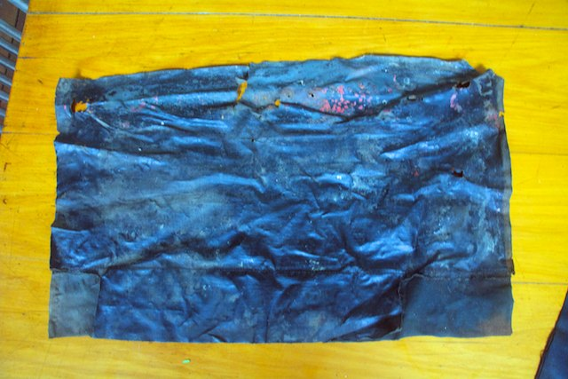
Figure 1 sealed oilskin surface that is against the metal of the door.
At the base of the sealing membrane, an additional 3 ½” strip of material is sewn on the outside of the main sheet of oilskin. This added piece is glued to the door and the section of the large piece of material is trimmed so that it can pass into the door opening. The allows a continuous path for any water that enters the doors. On my car, it appeared as though the section at each end had been torn off to make the flap fit the door opening. The arrangement of the flap would reduce the chances of water entering the car and channel it into the bottom of the door where it can exit via the drain holes.

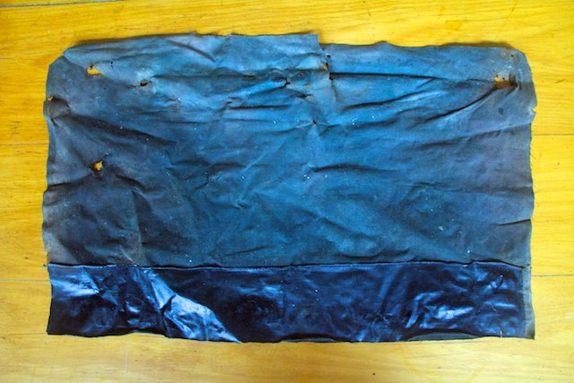
Figure 2 interior surface of the sealing membrane. Note holes for door handles and door-pull.

Modern cars use a sheet of plastic glued to the inner door face to prevent moisture ingress and whilst this may be used when rebuilding the doors. Plastic may degrade and crack so I retained the original style of seal, which had been working satisfactorily for over 50 years. Oilskin is readily available from upholstery suppliers and is not expensive. I applied a mixture of warm mineral turpentine, linseed oil and melted bees’ wax with a brush and then heated with a heat gun to ensure an even and thorough coating.
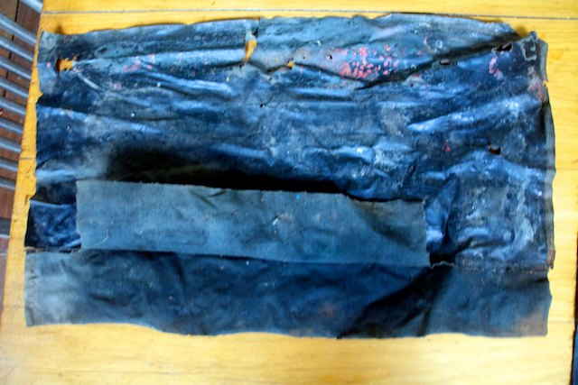
Figure 3 Sealing membrane showing the secondary flap folded up.

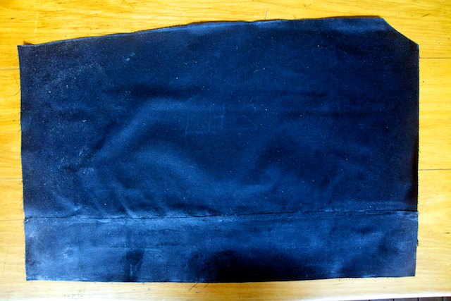
Figure 4 Seal for left door showing the side pacing the door panel.

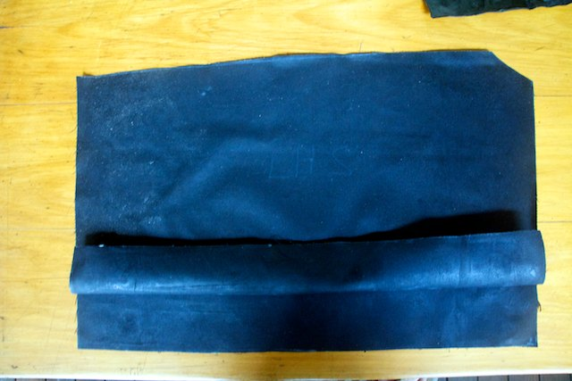
Figure 5 The side facing the door with the flap folded up to show the double layer of oilskin. This will be trimmed once fitted to the door.
Figure 6 Dimensions of the oilskin membrane.

