MGA Archaeology - MGA Twin Cam SRX210 chassis no. YD3/627/S

Steve Dixon - in collaboration with Bob West

Research continues to establish with greater certainty the evolution of SRX210 from its believed 1955 Le Mans roots as an EX182 prototype. Much evidence has been assembled indicating that the body of the car is indeed that of LBL303, chassis EX182/40, the Ted Lund car at Le Mans 1955, just as the man himself always said.
Having said that, there are some caveats.
Firstly, any research and resulting evidence is potentially flawed. Opinions, facts, estimates and the like are all subject to later scrutiny which can always overturn them. Nothing is absolutely certain.
Secondly, when we talk of the body of SRX210 as if it is a single, integrated, unit we should remember that whilst it started life as the beautiful dark green-painted alloy body of the EX182 at Le Mans it was all downhill thereafter. At various times elements of it would have been replaced and repaired. As we see the body today, only the inner panels (the “tub”) are original. Wings, doors, front shroud, hard top/rear shroud are all later additions. The nearside sill is steel. Even the vertical and horizontal elements of the front firewall are not original (occasioned by installation on a twin-cam chassis). The expression “EX182 body” must be seen in this light.

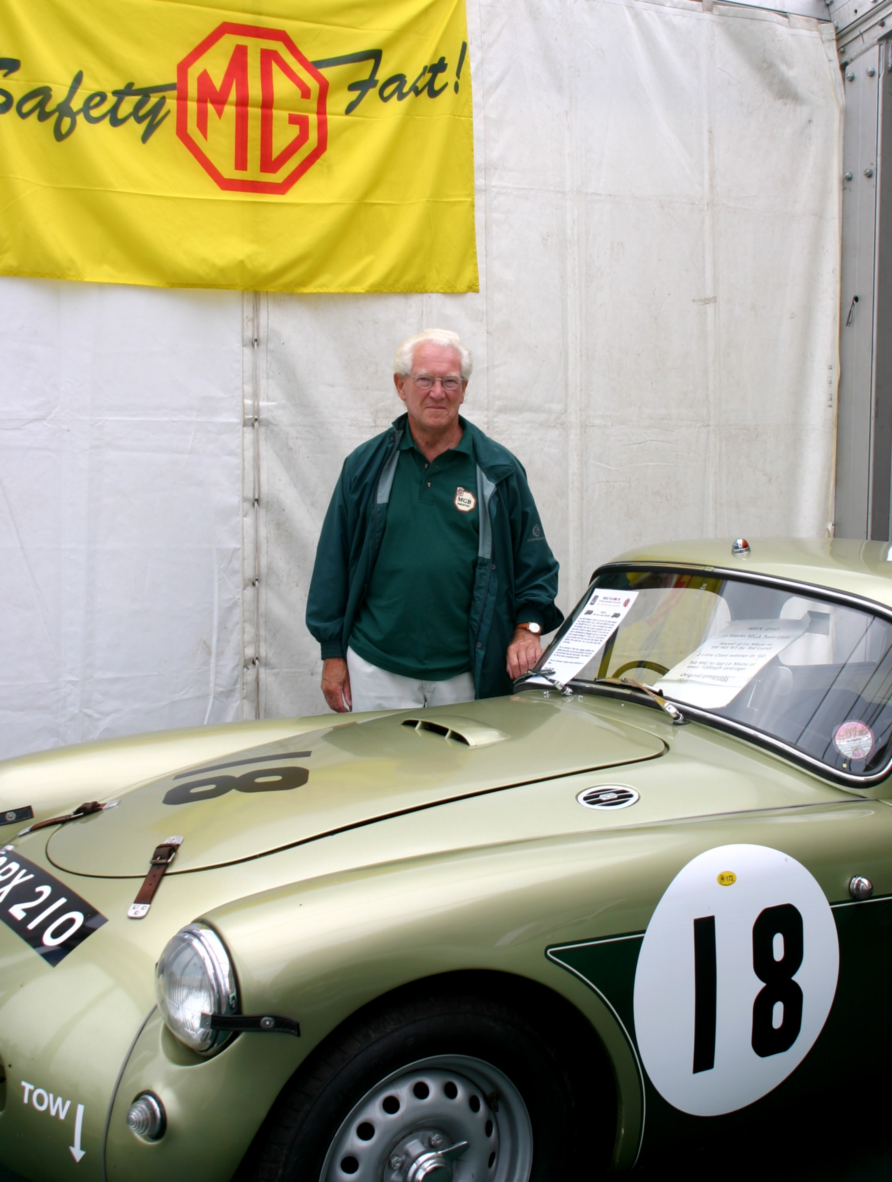
Don Hayter reunited with SRX210
Photo: Piers Hubbard

Chassis number - correction
The chassis number of this car was always YD3/627/S and not YD3-623 as stated in 'Call it MGA'. In fact, YD3-623 never existed but YD1-623 did and is a relatively standard car that still exists in South Africa.
The confusion seems to arise with the article that appeared in Thoroughbred & Classic Cars magazine in January 1975. This quotes the number as “YD3623 S”. It may be, though, that the magazine was merely repeating erroneous information in the Twin-Cam Group’s Production Records list, which also made the same mistake.
Interestingly, the original log-book, showing the M.G. Car Company as the first registered owner on 3rd June 1959 (just 9 days before Le Mans) shows the chassis number as YD3/627/F (not /S).
The original chassis-plate and the Abingdon production records are clear that the number is YD3/627/S. In the records the /S is added in blue crayon after the sequentially-stamped number 627 on 3rd September 1958.
The official results from Le Mans for the three years 1959/60/61 show that the car had the chassis number YD3/627/S (although the “S” appears as “5” for 1959!).

The Swiss Keller car
A diary kept by Cliff Bray of the Abingdon Developments Dept. records that on 9th August 1958, he drove what he described as “the EX182” to Switzerland for a hillclimb at Gaisberg and a race at Zeltweg driven by Heinz Keller, B.M.C.’s Swiss agent. He was accompanied by Alec Hounslow driving PJB147, the Twin-Cam demonstrator. They stayed for eight days and both cars were left in Switzerland. Exactly when or how the cars were returned is unknown. We know that PJB147 came back, of course, and must assume that “EX182” did as well.
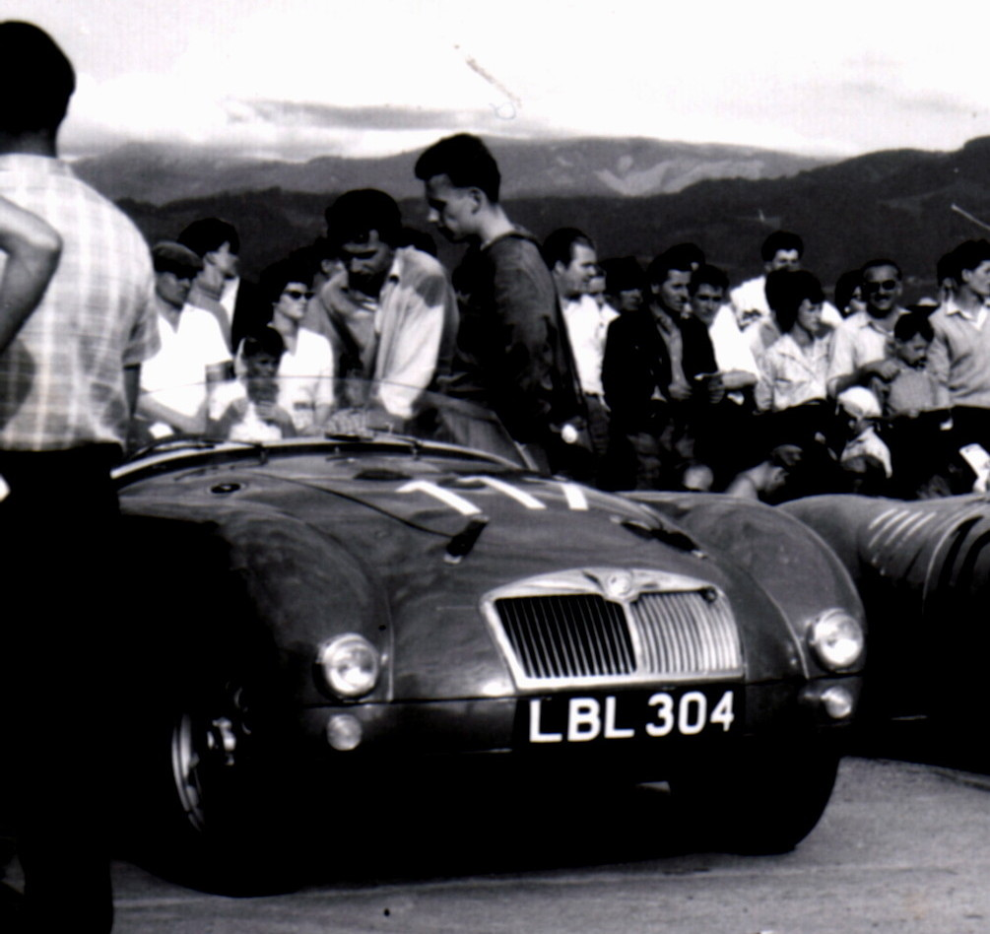
The Keller car at Gaisberg in 1958
The car had the registration LBL304, seemingly another example of Abingdon’s penchant for switching number plates if we are to believe the evidence that the car was, in fact, the body of EX 182/40 as had been LBL303 at Le Mans.
The right-hand drive car had a twin-cam chassis and engine and was painted red. It had the low-headlight front wings as seen three years earlier on LBL301 at Dundrod and, as a result, the sidelights were mounted lower, on the flush valance itself.
Stripped for restoration in 1990, the inner panels of the body on SRX210 were found to have been painted red over the original dark green for Le Mans 1955 and then Tyrolite Green for Fitzwilliam in 1957. Subsequently, Ash Green was used at Le Mans in 1959 and the later (and current) metallic green for Le Mans 1960 & 1961.

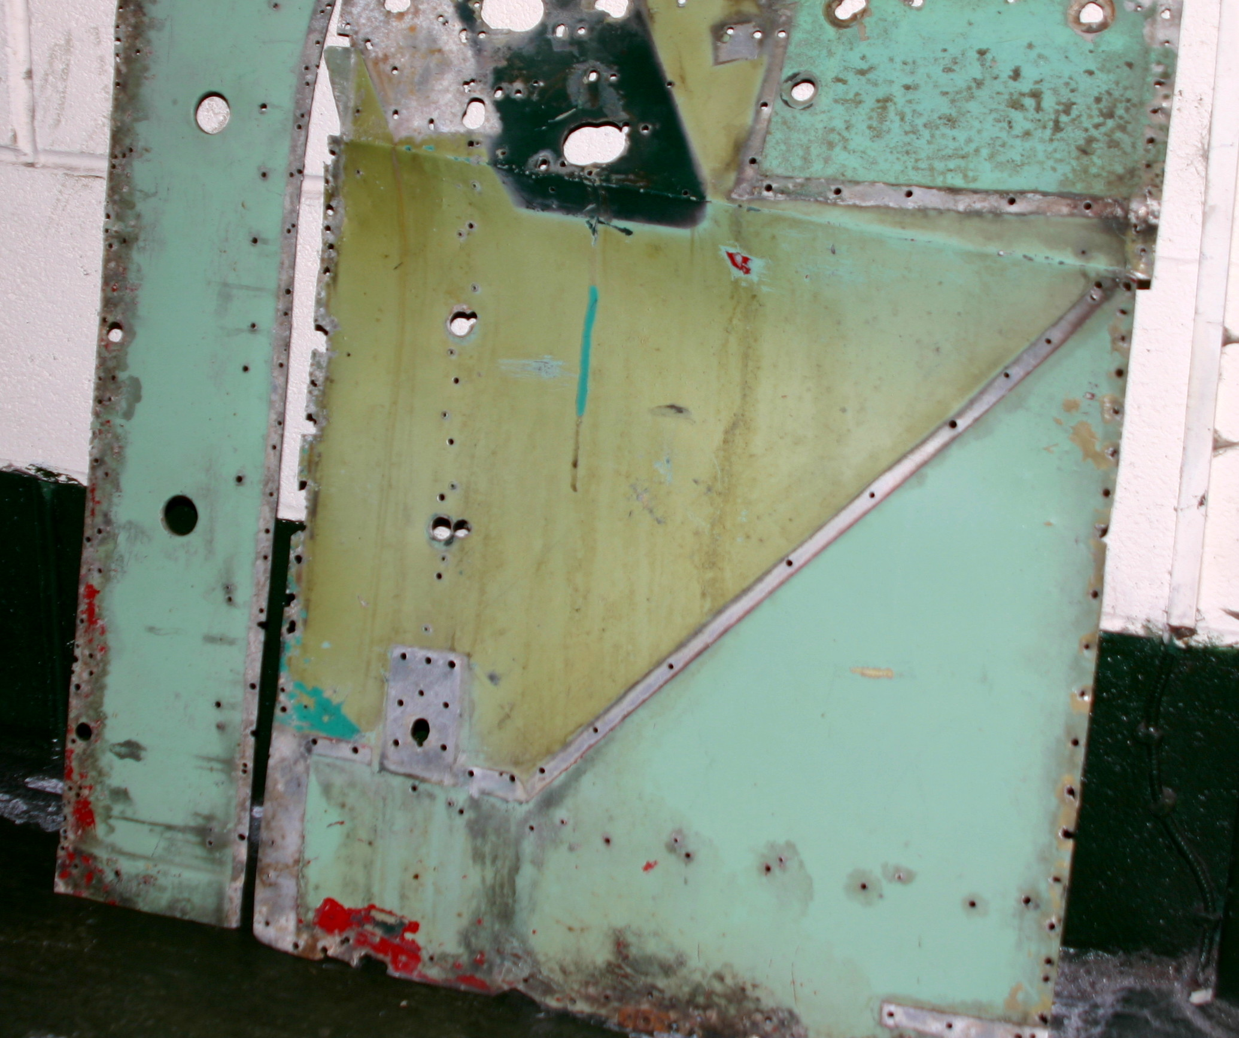
Panels showing dark green, red, Tyrolite and Ash greens
Photo: Piers Hubbard

Photographs of SRX210 at Le Mans in June 1959 with the Le Mans-style front valance clearly show covers over, presumably, the holes left on removal of the sidelights.
However, the Keller car had a standard fuel-filler, lacking the big centre-boot filler of the EX182. Neither did it have the EX182 air-intake low on the front off-side of the shroud.
Presumably, a standard fuel-tank on the new chassis was all that was required for short-distance racing. The body thus required only a boot-lid and a new hole in the rear shroud. The front shroud may well have been replaced after the car was damaged with Fitzwilliam in 1957 “beyond worthwhile repair for further competition” (most likely an excuse, the Works having exhausted its patience with Fitz after the frequent need for accident repairs). It was at that time, it is thought, that a steel sill was fitted on the near-side and is still on the body today.
An odd issue here is the YD3 chassis number prefix given to SRX210, which is normally given to a left-hand drive car for export. Also, production records list the car painted red with a miles speedometer. In fact, the car was always right-hand drive and red is not the original colour. The reason for all this may never be known with absolute certainty but it does fit with other information below that evidences the history of the car from its EX182 roots at Le Mans 1955.
The production records show 627/S commencing build on 3rd September 1958, completing on 17th November. The advice, despatch and invoice dates are not completed, being blanketed with the words “Completed in Development Shop” and dated 8/1/59. None of these dates bear any sequential relationship with those for cars built immediately before or after. For instance, chassis no. 623, mentioned above, was started on 16th, finished on 24th and despatched on 29th, all in September.
The number 627 is said to be stamped on the chassis as is usual, revealed when the car was being restored.
Having created a Twin-Cam “EX182” for August 1958 it seems most unlikely that the Works would have dismantled it and built the body onto another chassis just a month or so later. There must be a strong probability that the whole Keller car and SRX210 are one and the same.
It is only conjecture but a possible reason for this strange chronology could be that Abingdon, forbidden to race yet always seeking to get back to Le Mans (witness the EX186 saga) disguised the new twin-cam as LBL304 under the aluminium body, labelled EX182. Having built the car, it had to be regularised in the production records when the car was returned and so the chassis number and record was created. There may also have been the usual efforts to somehow reduce the effect of taxes or duties.
Then again, the body of the Keller car could have been once again transferred, this time onto a second new twin-cam chassis, numbered 627/S!
One could only imagine what the obviously added /S meant - was it Special or Sports or even Swiss/Switzerland?

SRX210 before 1959
The well-documented story of SRX210 starts in 1959 and comprises the three visits to Le Mans in 1959, 1960 (when it won the two-litre class outright) and 1961. However, the real story of SRX210 started earlier.
It now seems that its body was indeed at Le Mans in 1955 and in the 1957 Mille Miglia, albeit as a pushrod-engined car, chassis EX 182/40, LBL303, exactly as Ted Lund himself always said to anyone who would listen.
From the visual evidence available there seems to be no doubt that this is indeed the case:
~ The body is aluminium and well used, given the amount of modification and adaptation evident. It was fitted on a pushrod chassis before it sat on a twin cam chassis, for sure.
~ It is a roadster body. The coupe top has been added and is riveted to the roadster body in very evident places, e.g. the tops of the A & B posts, whilst the old tonneau “lift-the-dot” holes remain in the trailing top edge of the front shroud.
~ The body design is that of a pushrod-engined car, and a very early one at that. For example, the duct-panel is turned-back to accommodate the twin-cam radiator. The carburettor-clearing indentation on the nearside front inner wing is round. The boot floor is of the very early hand-built pattern.
~ The bonnet has the 1500 “flat” profile and has two unique half-round cut-outs in the frame at the front. These, it is believed, may be the result of fitting the Austin twin-cam engine with its bulky ducting/pipework at Dundrod in 1955.
~ As described above, colours were found on the body that reflect various incarnations from Le Mans 1955 to Le Mans 1961. Some inner panels were removed & retained, showing these colours in sequence. The two EX182’s loaned to Fitzwilliam in 1957 were EX 182/40 (LBL303) and EX 182/41 (LBL 304 - the spare car at Le Mans – but now wearing LBL 301 for Fitz). Both were painted Tyrolite green, which rather narrows the field.
~ Photographs of LBL303 consistently show a unique feature. The upper leading edge of the driver’s door sat well-away from the trailing edge of the front wing showing an evident gap. This feature is visible at Le Mans 1955, at Dundrod 1955, with Fitzwilliam (the “red” Tyrolite green car) in 1957 and then as the Keller car in 1958. No other EX182 had such a feature. This “gappy” door was lost for the 1959 Le Mans entry but the other carry-overs from the Keller car are visible and, in any event, it is probable that the wings, by now steel, were of a slightly different profile and/or the door had been altered or changed.

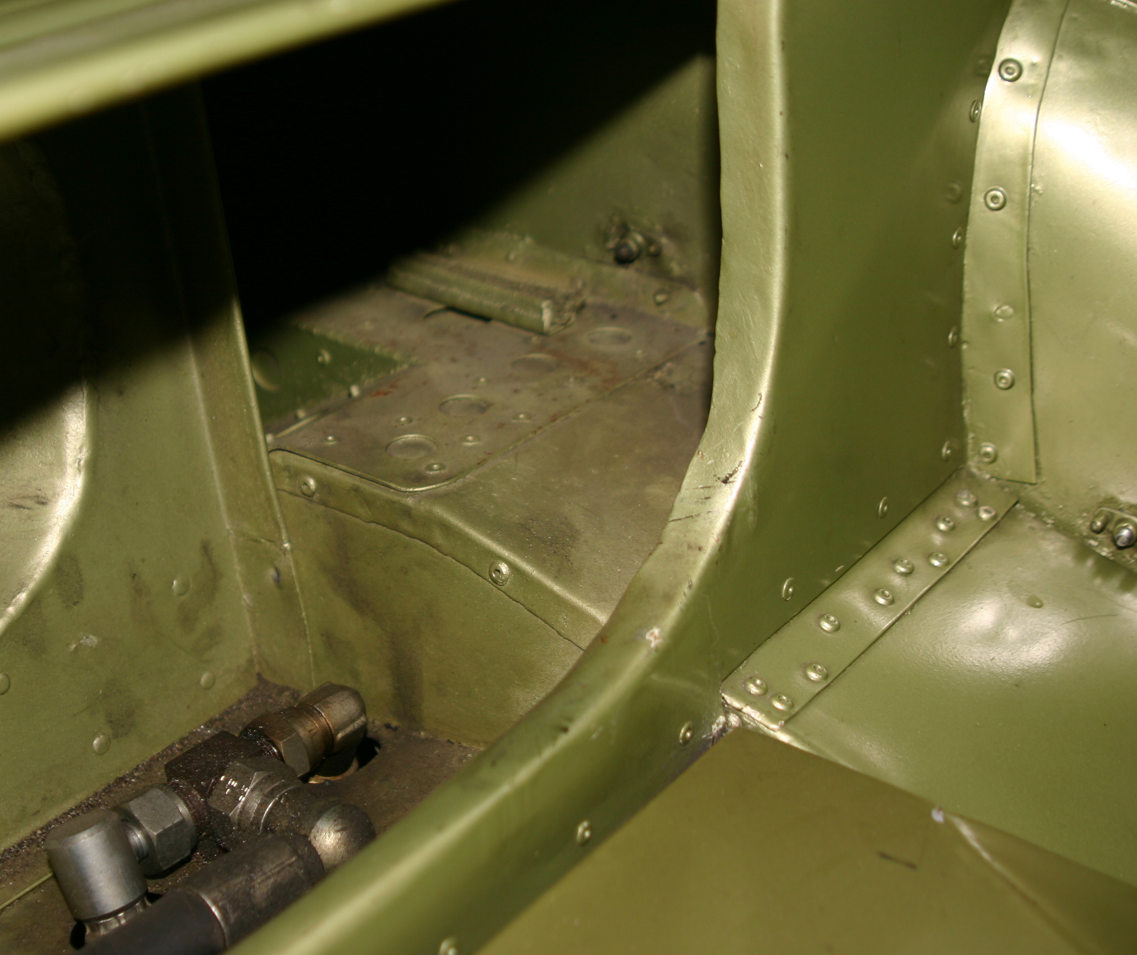
Body panel rivet detail
Photo: Piers Hubbard
Documentary evidence makes it clear that the body is from an EX182 but unhelpful as to which one. The August 1960 edition of Safety Fast, written days after Le Mans, tells how the body of an EX182 was fitted to SRX210 for 1959. Written and published contemporaneously there can be no more reliable documentary evidence.
It has to be said that there are still some issues that will probably never be resolved. For example, why did the “gappy” door disappear for Le Mans 1959? What happened to the air-vent low on the off-side of the front shroud after 1957? Why is the near-side sill made of steel? What happened to the Le Mans fuel-filler for the Keller car? How much of the Keller car became SRX210? Why do the production records for chassis 627/S seem way out of sequence compared with adjacent chassis numbers?
Such matters can be explained hypothetically and often with quite valid argument. The truth is that we will probably never know. And so an element of doubt exists. Hopefully, that doubt is more than outweighed in the “balance of probabilities” when set against the quantity and quality of positive evidence.
So it seems clear that SRX210 (well, its body anyway), does indeed have a wide and fascinating history. Not just three visits to Le Mans in 1959-61 but an earlier visit there in 1955, the TT in 1955, Mille Miglia 1957, Nurburgring 1957, Goodwood 1957, Gaisberg and Zeltweg 1958 and many more besides. Apart from 1956, that is continuous top-flight competition from 1955 to 1961, albeit on two different chassis.

Footnotes
There is a continuing effort to establish the history of SRX210 and its EX182 predecessors. New facts emerge frequently. For example, during 2006, the Jerry Goguen “EX182” car from New England that now belongs to Jon Savage will be dismantled by Bob West and it is possible that more information will emerge.
Rob Higgins, former historian of the MGA Register, wrote “A Potted History of the MGA” more than 10 years ago. This, easily the most authoritative work about the early Works cars, will be updated, amended and augmented in the coming months to include the latest information.
We would like to trace any information, however tenuous, that there may be of an American serviceman named Southam who drove a “red aluminium-bodied Le Mans MGA” in competition here in England in the late 1950s. This may yet be a missing link.
There will be readers that can add to the fund of knowledge about these cars. Inexorably, time takes its toll so that many potential contributors are no longer with us, making information ever harder to get. What is written here is believed to be true but there is always the potential for contrary views or information to emerge.

(Steve Dixon would like to point out that he is the keeper of SRX210 now that it has been transferred by Bob West to its new owner)

